The Supermarket App Example

The data flow diagram is a hierarchy of diagram consist of:

1. Context Diagram (conceptually level zero)
2. The Level-1 DFD
3. And possible Level-2 DFD and further levels of functional decomposition depending on the complexity of your system.

Context DFD

The figure below shows a context Data Flow Diagram that is drawn for an Android supermarket app. It contains a process (shape) that represents the system to model, in this case, the "*Supermarket App*". It also shows the participants who will interact with the system, called the external entities. In this example, there is only one external entity, which is the *Customer*. In between the process and the external entity, there is a bi-directional connector, which indicates the existence of information exchange between customer and the app, and the information flow is bi-directional.

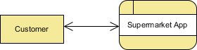

Context DFD is the entrance of a data flow model. It contains one and only one process and does not show any data store, which makes the diagram simple.

Level 1 DFD

The figure below shows the level 1 DFD, which is the decomposition (i.e. break down) of the Supermarket App process that is shown in the context DFD. Read through the diagram and then we will introduce some of the key concepts based on this diagram. 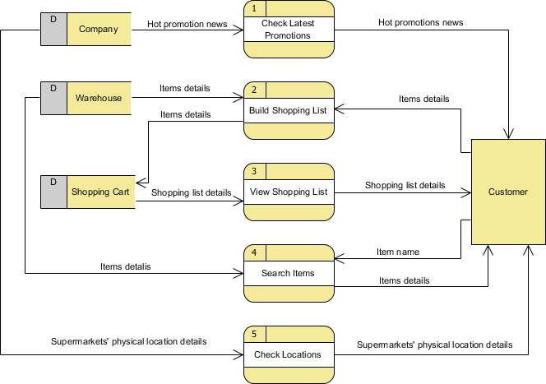

The Supermarket App Data Flow Diagram example contains five processes, one external entity and three data stores. Although there is no design guideline that governs the positioning of shapes in a Data Flow Diagram, we tend to put the processes in the middle and data stores and external entities on the sides to make it easier to comprehend.

Based on the diagram, we know that a *Customer* can receive *Hot promotion news* from the *Check Latest Promotions* process and the news is provided by the *Company* database. Note that by common sense we know that *Check Latest Promotions* is likely to be a feature of the app but the Data Flow Diagram itself implies no such thing. Theoretically speaking, a process in Data Flow Diagram may correspond to a feature or a set of features.

A *Customer* can *Build Shopping List* by providing *Items details* and the details will be stored in the *Shopping Cart* database. The *Warehouse* database will also provide the *Items details* required to complete the process.

A *Customer* can receive *Shopping list details* from the *View Shopping List* process and such details is provided by the *Shopping Cart* database.

A *Customer* can receive *Items details* by performing the *Search Items* process. He/she must provide an *Item name* for searching and the *item details* are returned from the *Warehouse* database after searched. Although we said that the search result is returned after searching, the Data Flow Diagram, again, implies no such thing. It is our common sense that leads us to interpret the diagram in the way that we understand it naturally. Keep in mind that Data Flow Diagram only tells you where information exchange takes place. It does not answer in what way and in what order the information is being used throughout a system. If this information is important and worth mentioning, consider to model it with diagrams like [**BPMN Business Process Diagram**](https://www.visual-paradigm.com/features/bpmn-diagram-and-tools/#business-process-diagram) or [**UML Activity Diagram**](https://www.visual-paradigm.com/features/uml-tool/#activity-diagram).

Finally, a *Customer* can receive *Supermarkets' physical location details* by performing *Check Locations* and the details is provided by the *Company* database.

Data Flow Diagram Tips and Cautions

Be aware of the level of details

In this Data Flow Diagram example, the word "details" is used many times when labeling data. We have "item details", "shopping list details" and "location details". What if we write them explicitly as "item ID", "item name, description and photo" and "country, city and address of supermarket"? Is this correct? Well, there is no definite answer to this question but try to ask yourself a question when making a decision. Why are you drawing a DFD?

In most cases, Data Flow Diagram is drawn in the early phase of system development, where many details are yet to be confirmed. The use of general terminologies like "details", "information", "credential" certainly leave room for discussion. However, using general terms can be kind of lacking details and make the design lost it usefulness. So it really depends on the purpose of your design.